Fan Lamp

Subject: Physics, Electronics  Related Subjects: Architecture, Civil Engineering | Grade Level(s): 2 - 6  Length of Lesson: 90 minutes | Type: Project  Keywords: Inches, perpendicular, concave, cone, series-parallel, propeller, displacement

Lesson Overview
Students will build a series-parallel circuit to power a motor and bulb to create the fan lamp. They will also build the structure that houses the fan and bulb.

Lesson Focus
How can we use a series-parallel circuit to power multiple components safely and efficiently? How do form and function come together in engineering design?

Lesson Objective(s) | - Students create a series parallel circuit with motor and bulb.  - Students construct a box to hold a bulb and a motor to create a fan lamp.  - Students generate airflow by orienting fan blades.  - Students create cones to reflect and disperse light.

Lesson Timing

5 minutes | Introduction and circuit concept review
60 minutes | Structure building and electrical assembly
10 minutes | Testing and troubleshooting
5 minutes | Wrap-up and demonstration

Materials | - Foam board  - Hot glue gun  - Hot glue sticks  - Drill  - Drill bits  - Switch  - Pencil  - Insulated wire  - 2AA batteries  - Light bulb with wire leads  - Motor  - 1/4” dowels  - Coffee filter  - Mylar sheet  - Xacto knife  - Wire stripper/cutters  - Soldering iron  - Solder  - 3x5 card holder  - Tape
Instructor Prep | - Pre-cut foam board squares.  - Prepare drill stations or pre-drill holes if needed for younger students.  - Review safe use of soldering irons and glue guns.  - Test circuit layout in advance using a diagram similar to Figure 2 in the original material.
Related Resources | - Circuits - Lesson - TeachEngineering  - Let's Review the Basics: How Do Fans Work?  - Series-Parallel circuit - Online Circuit Simulator | DCACLab

Lesson Plan

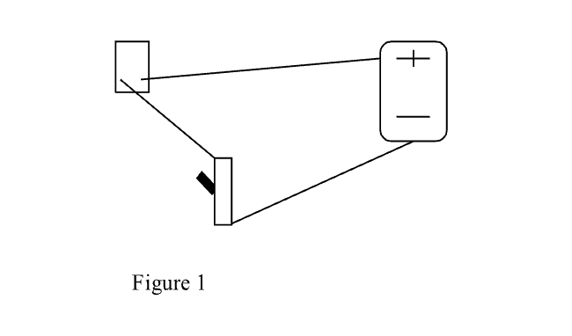
Introduction

A series circuit is formed when an electrical source (battery) is connected to an object (motor, light…), which is connected to a switch, which is connected back to the battery.

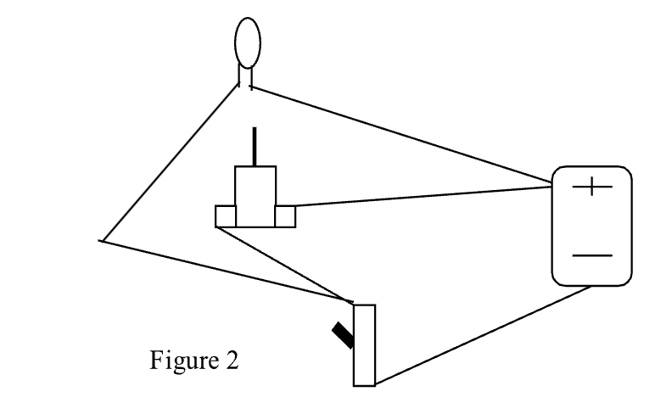
When the switch is off, the circuit is open and electricity can’t flow. When the switch is on, the circuit is closed and electricity can flow. In this instance, a series-parallel circuit occurs when two objects are connected to the same two points (a parallel connection) in the series circuit.

The light and motor of the fan lamp should be connected in the same manner as shown in figure 2.
A carefully constructed box will house the fan lamp.

Safety Procedures
- Students must exercise caution using Xacto knife
- Students must be careful when using glue guns and soldering iron in order to prevent burns.

Procedure
- Cut 5-5” squares of foam board.
- Drill 2” diameter hole in the center of one of the squares.
- Glue the remaining squares together in the shape of a box (without a bottom or top).
- Use a pencil to poke two holes 2” apart in the center of one of the sides (this will be the back of the fan lamp).
- On the side opposite (the front) drill a hole large enough to insert the motor snuggly.
- Strip the wires of the battery holder.
- Glue battery holder beneath one of the holes on the outside back of the fan lamp.
- Insert wires from the battery holder through the hole.
- Cut 2-3” wires and strip ends.
- Solder one wire to the center post of the switch.
- Solder the other wire to either outer post of switch.
- From inside of the fan lamp push the stem of the switch through the remaining hole on the back of the fan lamp.
- Cut 2-3” wires and strip ends.
- Solder one wire to one motor lead and the other wire to the remaining motor lead.
- Attach propeller to motor
- Test motor with battery to see which end positive battery must touch to make the propeller blow air toward you.
- Mark wire with tape
- Remove the propeller.
- Strip wire leads from bulb.
- Twist one lead from the bulb with tape wire from the motor.
- Twist remaining lead from bulb with remaining wire from motor.
- Twist twisted pair with taped motor wire with center post wire from switch.
- Twist remaining twisted pair with either wire from battery holder.
- Twist red wire from battery holder with outer post wire from switch.
- Cut 4”-squares of mylar.
- Create cone from mylar square and insert bulb through bottom of cone and tape in place
- Mount cone with bulb in 2” hole of unattached foam board square and glue in place.
- Glue foam board square to top of box.
- Push motor through front hole in box from the inside
- Attach propeller to motor.
- Insert batteries into battery holder
- Cut 4-4” dowels
- Glue in place on top of fan lamp round the light hole
- Place the coffee filter upside down on the wood dowels.
- Try out your fan lamp.

Wrap-up
Let students test their fan lamp, adjust airflow direction, and observe how light reflects through the cone. Discuss the process and identify where structural design and electrical function overlapped.

Lesson Background for Teachers
This activity integrates electronics with structural design. Students apply real-world circuit logic—learning how a series-parallel system allows both a motor and a light to operate from one power source. It also emphasizes design thinking, as students must create a functioning, stable structure that houses all components effectively.

Suggested Real-World STEM Connections
- Electrical Engineers who design home appliances and circuits
- Product Designers who merge aesthetics with function
- Industrial Engineers who optimize systems combining electronics and materials

Lesson Variations and Options
- Students can try color transparency sheets to make different colors.
- Replace fan blades with different materials to explore airflow

Explanation
A series-parallel circuit lets two components share power efficiently: both the motor and the bulb are powered through connections to the same battery. When the switch is closed, electricity flows through the circuit. The structure of the fan lamp supports both components, and the fan blades demonstrate airflow principles while the lamp shows reflection and light diffusion.

Key Concepts and Vocabulary
- Series Circuit: Components connected one after another
- Parallel Circuit: Components connected across the same two points
- Air Resistance: A force that slows objects moving through air
- Reflection: Bouncing of light off a surface
- Propeller: Rotating blades that move air

Safety Notes
- Students must exercise caution using Xacto knife
- Students must be careful when using glue gun and soldering iron in order to prevent burns.

